Chapter 6, Solution 63.

We apply superposition principle and let

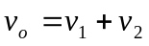

where v₁ and v₂ are due to i₁ and i₂ respectively.

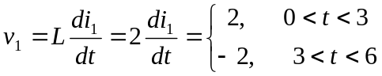
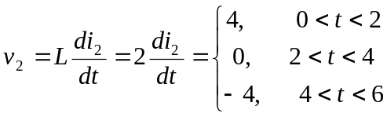
v₁
v₂

2 4

0
3 6 t 0 2 4 6 t

-2 -4

Adding v₁ and v₂ gives v_{o}, which is shown below.

v_{o}(t) V
6

2

0
2 3 4 6 t (s)
-2

-6

